**Project Name** :- Creation of machine learning model

**Presented by**:- Group_4

**Presented to**:- Mr.Keshav

**Introduction**

We would like to extend our gratitude to Mr.Keshav for giving us an opportunity to work on the amazing project “Building machine learning models” in which we learnt to built machine learning model using machine learning algorithm .In this project we performed seven steps of machine learning model process.

**Summary of project:-**

We used dataset “teams.csv” in our project.After observing the various details of dataset ,we cleaned the data i.e removing null values ,handling missing values and duplicate records by using various function provided by pandas library.to built a machine learning model we used [“athletes”,”prev_medals] as input variables and [“medals”] as target variable. Further we analysed relationships between these variables using matplotlib.pyplot library. Following Interesting pattern were seen in the dataset :

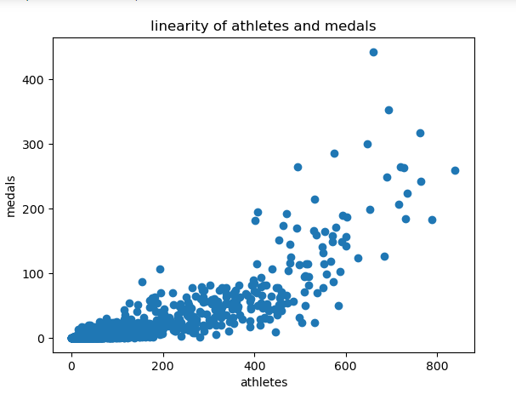

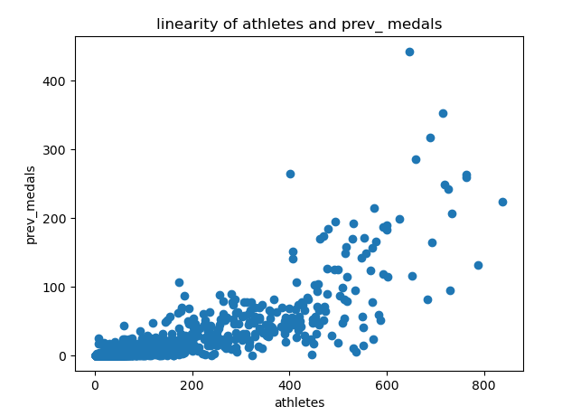

Both the input variabes athletes and prev_medaals met the linearity assumption of linear regression model

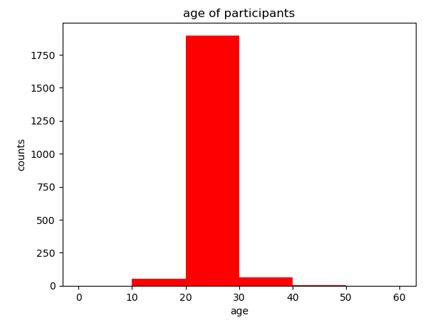.

The majority of participants in Olympics are from age group of 20 – 30

Further LinearRegression() was imported from sklearn library. The data was split into training and test dataset with the 80% and 20% split approximately. The training data was trained using fit() function which lead to the creation of best fit line. The test data was provided and target variable was predicted.The analysis of the model was done by using error matrix.

**Conclusion and outcome of project:-**

In the given project we learn how to built the machine learning model by using an appropriate machine learning algorithm which was linear regression for the given dataset.we learnt that the lesser the error rate of model accurate the model would prediction. If the error rate is high,we might have to use another machine learning algorithm or ensemble machine learning techniques to build a better prediction model.